**INSTRUCTIONS FOR RUNNING**

In these .docx i'll give you some detail advices how to run this client-server application.

I. First we need to start the server (remote service), for what:

1. Generate the stubs (client helper) and skeletons (server helper) using rmic - these are the client and server "helpers". You don't have to create these classes or ever look at the source code that generates them. It's all handled automatically when you run the rmic tool (that ships with your JDK) in terminal.

Note that rmic should run with .class file, not with .java, but without .class extension like you’ll see below:

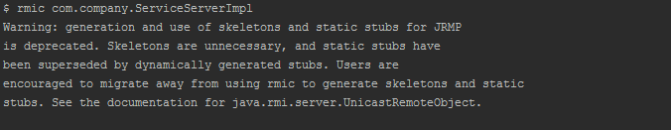

In my case «com.company» is the name of the package.

2. Start the RMI registry in terminal. The rmiregistry is like the white pages of a phone book. It's where the user goes to get the proxy (the client stub/helper object). The rmiregistry should work in the background.



3. Open next one terminal and start the remote service (ServiceServerImpl.java). The remote service should work in the background.

II. And now we'll start the client (ServiceBrowser.java) and having fun.